AUTHORITY TO DEBIT ACCOUNT

Given By: (Name of Account Holder)
Address:
Bank: |  |  |  | Branch Code:
Account Number: |  |  |  | Account Type:
Amount:
Date:
To: (Name of Beneficiary) | BrainLife Tshwane
Beneficiary Address: | 513 Rossouw Street, Wilgers; Stanza Bopape Clinic, Mamelodi
Abbreviated name: (As it will appear on your bank statement)
For Office Use: (Agreement Reference number)

This signed Authority and Mandate refers to our contract dated_________________________ (“the Agreement”)  I/We hereby authorise you to issue and deliver payment instructions to your Banker for collection against my/our abovementioned account at my/our above-mentioned Bank (or any other Bank or branch to which I/we may transfer my/our account) on condition that the sum of such payment instructions will never exceed my/our obligations as agreed to in the Agreement, and commencing on ____________________________ and continuing until this Authority and Mandate is terminated by me/us by giving you notice in writing of not less 20 ordinary working days, and sent by prepaid registered post or delivered to your address indicated above.  The individual payment instructions so authorised to be issued must be issued and delivered as follows:  - On the _ ___ day (“payment day”) of the month commencing on_____________________. In the event that the payment day falls on a Sunday or recognized public holiday, the payment day will automatically be the very next ordinary business day. Furthermore, if there are insufficient funds in the (my) nominated account to meet the obligation, you are entitled to track my account and re-present the instruction for payment as soon as sufficient funds are available in my account;  - Monthly on or after the dates when the obligation in terms of the Agreement is due and the amount of each individual payment instruction may not be more or less than the obligation due.  If alternate Payment Dates are required:  Payment Instructions due in December and/or April may be debited against my account on ______________________ | I /We understand that the withdrawals authorised will be processed  through a computerized system provided by the Banks. . I also  understand that details of each withdrawal will be printed on my  Bank statement. Such must contain a number, which number must be  included in the said payment instruction and if provided to me should  enable me to identify the Agreement. This number must be added to  this form in Section D before the issuing of any payment instruction.  - MANDATE  I/We acknowledge that all payment instructions issued by you shall be treated by my/our above mentioned Bank as if the instructions had been issued by me/us personally.  - CANCELLATION  I/We agree that although this Authority and Mandate may be cancelled by me/us, such cancellation will not cancel the Agreement. I/We shall not be entitled to any refund of amounts which you have withdrawn while this Authority was in force, if such amounts were legally owing to you.  - ASSIGNMENT  I/We acknowledge that this authority may be ceded or assigned to a third party if the Agreement is also ceded or assigned to that third party, but in the absence of such assignment of the Agreement, this Authority and Mandate cannot be assigned to any third party.

Signed at __________________________on this ___________day of ___________________________

_____________________________________ _______________________________________
Signature as used for operating on the account Assisted by

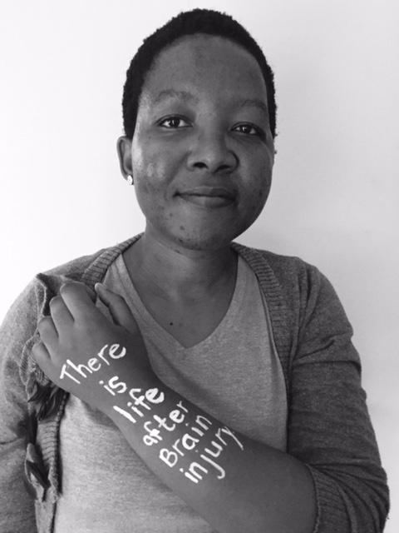 | An R 100 can change the world…….  Please consider joining our R 100 a month campaign. With your help we can continue to support people with brain injury and their families.  Brainlife is a registered and audited NPO and you can be sure all funds are used where they are needed most …. on the ground.  Yearly reports and 18 A certificates is provided and visits and volunteering is always welcome.

